**Let’s Tour Pakistan**

Final Year Project Proposal



**Supervisor**

Dr. Madiha Khalid

**Submitted By**

Iqra Sarwar - BSEF19M012

Mahnoor - BSEF19M027

**Department of Software Engineering**

Faculty of Computing and Information Technology,

University of The Punjab.

**CONTENTS**



|  |  |  |  |
| --- | --- | --- | --- |
| **1** | **Introduction** | | **3** |
|  | 1.1 | Project Title | 3 |
|  | 1.2 | Project Overview Statement | 3 |
|  | 1.3 | Project Goals & Objectives | 5 |
|  | 1.4 | High-level system components | 5 |
|  | 1.5 | List of optional functional units | 5 |
|  | 1.6 | Exclusions | 6 |
|  | 1.7 | Application Architecture | 6 |
|  | 1.8 | Gantt chart | 7 |
|  | 1.9 | Hardware and Software Specification | 7 |
|  | 1.10 | Tools and technologies used with reasoning | 7 |

## 1. Introduction

## 1.1 Project Title

Let’s Tour Pakistan

## 1.2 Project Overview

## Statement:

With tourism in Pakistan on the rise, we want to provide a platform that will make it easier for tourists to explore the country. We will provide an online marketplace that will allow tourists to book tour packages or plans, as well as create and share blog posts about their experiences. The platform will also allow them to use our online payment system and other necessary features to plan their trip.

**Project Title:**

Let’s Tour Pakistan

**Group Leader:**

Iqra Sarwar

**Project Members:**

|  |  |  |  |
| --- | --- | --- | --- |
| Name | Registration # | Email Address | Signature |
| Iqra Sarwar | BSEF19M012 | bsef19m012@pucit.edu.pk |  |
| Mahnoor | BSEF19M027 | bsef19m027@pucit.edu.pk |  |

**Project Goal:**

To develop an online marketplace that will help tourists plan the perfect vacation by providing them easy and convenient access to Pakistan's tourism attractions. It will promote Pakistan's tourism industry by providing a one stop solution for all of the tour needs.

**Project Objectives:**

| **Sr.#** | **Statement** |
| --- | --- |
| 1 | Provide an easy to navigate hierarchical interface of tourism spots. |
| 2 | Provide facility to service providers to offer the services remotely |
| 3 | Provide facility to share articles, images and videos about tourism spots |
| 4 | Provide facility to book services online |
| 5 | Provide facility to pay online for services availed |
| 6 | Provide facility to share reviews and comment about services |
| 7 | Provide 24/7 help & support to the tourists |

**Project Success criteria:**

To be able to develop the desired platform that fulfills all of the above objectives within the time span of this project.

**Assumptions:**

* Service providers will share authentic information about their services.

**Risk:**

* Changing Government policies about tourism i.e. the domain rules
* Intense market competition and poor marketing strategies
* External factors like flood, pandemic etc will immensely cause us to lose our customers.

**Obstacle:**

* Unavailability or lack of data related to tourism

**Organization Address:**

Faculty of Computing and Information Technology, University of The Punjab, Allama Iqbal Campus, Shahrah-e-Quaid-e-Azam (The Mall), 54000 Lahore, Pakistan

**Type of project:**

Development

**Target End users:**

Tourists

**Development Technology**:

Structured

**Platform:**

Web based

**Project Supervisor**:

Dr. Madiha Kahlid

**Approved By**:

**Date**:

**1.3 Project Goals & Objectives**

**Goals:**

We aim at developing a website that will facilitate tourists across the country and assist their tours. Our website will help service providers in providing services to tourists and attract tourists to the worth seeing tourist spots in Pakistan by showing them the brighter side of Pakistan. It will provide better information regarding travel agencies, sightseeing, food areas, hotels, and pictures to help people choose destinations according to their interests.

**Objectives:**

* We want to provide an easy to navigate hierarchical view of provinces, cities, and tourism spots. This is to help people find the best spot in a province or city with just a few clicks.
* Service providers can offer their services remotely by signing up for flexible contracts. Services offered include transportation, tour guide, accommodations, food options and others.
* Tourists and Service providers can share their blogs, articles, photography and videos about tourism spots.
* Tourists can book suitable services remotely and pay for them online.
* Tourists can provide their reviews and comments about the services they availed. These reviews will help others to find out what others think about our services.
* Adding a help & support section for tourists will provide 24/7 assistance to users.

**1.5 High-level system components**

* A tree-like hierarchical structure of interface starting from provinces spanning into cities, spots, hotels, restaurants, etc
* Reviews and comments section about a tourism spot, hotel, or restaurant, etc
* Online payment system
* Online booking system
* Blog post section consisting of photographs and articles about spots
* Service from various kinds of external service providers
* In-app service plans
* Help and support section for tourists

## 1.6 List of optional functional units

* Tour recommendation system according to their time, budget, and interests.
* chatbot for help & support
* Scalability
* Maintainability
* Capability
* Availability
* Safety

## 1.7 Exclusions

* Support of multiple communication channels like audio, videos, online meetings, text messaging
* Support of international services like visa and flight etc
* Continuous content monitoring to filter outdated and spam content

## 1.8 Application Architecture

MICROSERVICES ARCHITECTURE

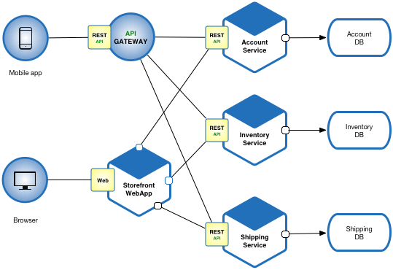

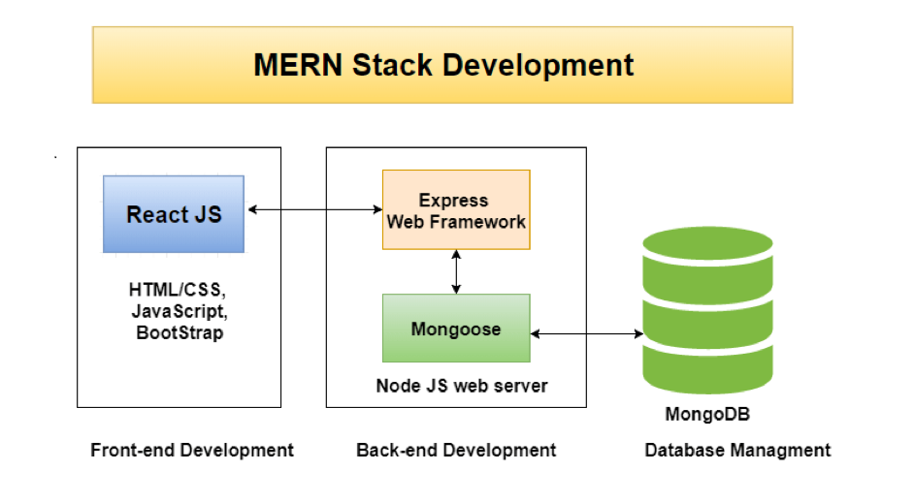

## 1.9 Gantt chart

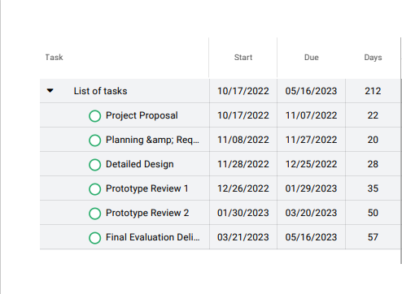

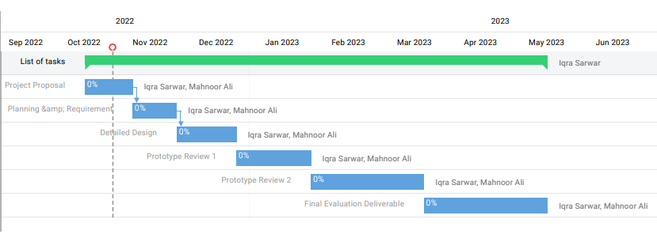

## 1.10 Hardware and Software Specification

## Hardware Specification:

* Dual core processor
* 2GB RAM
* 1GB free hard drive space

## Software Specification:

* Web browser on any Operating system

## 1.11 Tools and technologies used with reasoning

### Tools

|  |  |
| --- | --- |
| **Tools** | **Reason for Using** |
| VS Code | IDE for Web development |
| Proofhub | To create Gantt Chart |
| Figma | For application design |
| Heroku/Netlify | For website deployment |
| Trello | For project management |
| Postman | For API testing |
| Git, Github | For version control |
| Chrome Developer Tools | For debugging |
| Npm | To install and manage node packages |
| Docker | Containerize an application |

### Technologies

|  |  |
| --- | --- |
| **Technologies** | **Reasons for Using** |
| MongoDb | For no Sql database |
| Express | For Back-end web development |
| React | For Front-end web development |
| Node.js | For Back-end web development |
| JavaScript | Used as major development technology |